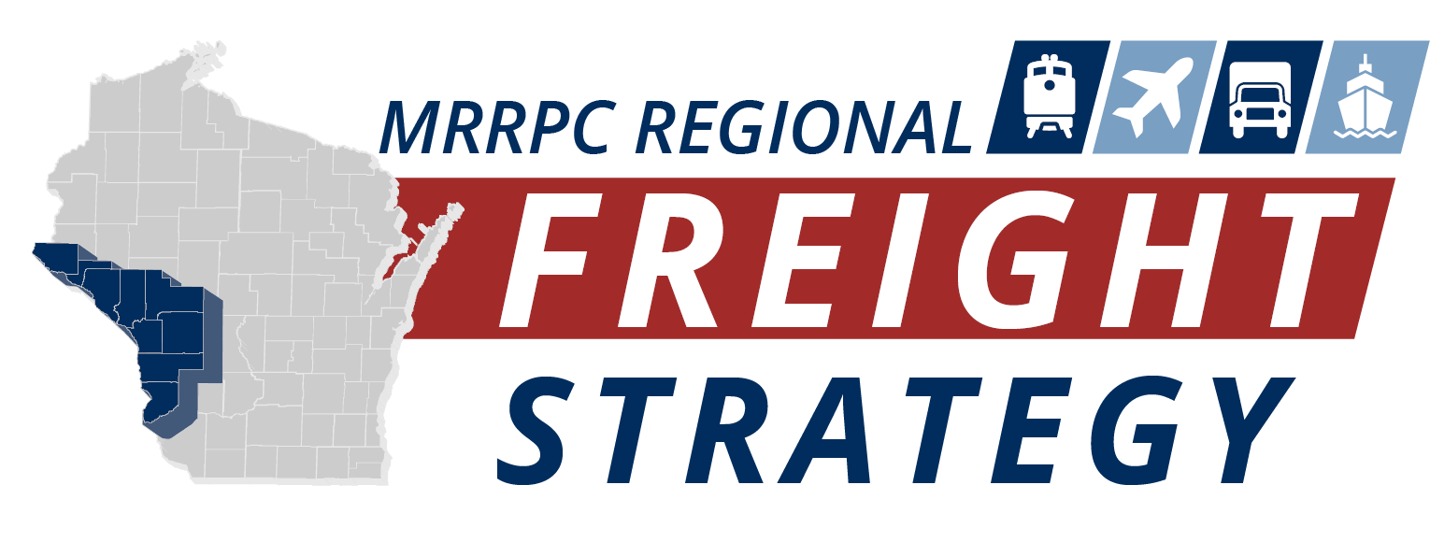

Table of Contents
Introduction 6
Modal Plans 6
Wisconsin State Freight Plan 7
Wisconsin Highway-Railway Grade Crossing State Action Plan 9
Wisconsin Rail Plan 2030 10
WisDOT Connect 2050 State Long-Range Plan 10
Wisconsin State Airport Plan 2030 12
Other Relevant Regional Plans 13
Community Economic Development Strategy (CEDS) 13
MRRPC Freight Strategy Goals and Objectives 15
MRRPC Regional Freight Network 17
Highway Network 17
National Highway System 17
National Highway Freight Network 18
Oversize Overweight Corridors 20
Bridges 23
Alternative Fuels Corridors 25
Truck Parking 27
Railroad Network 29
Waterway Network 32
Aviation Network 34
Pipeline Network 36
MRRPC Regional Freight Facilities 38
Intermodal Terminals 39
MRRPC Regional Freight Flows 41
MRRPC Freight Network Condition and Performance 48
Freight Network Condition 48
MRRPC Freight Network Performance 52
Highway (Truck) Safety 58
Rail Safety 61
Appendix A: Relevant Maps and Other Graphics 64

Table of Figures
Figure 1: WisDOT State Freight Plan Goals 7
Figure 2: Wisconsin Statewide Freight Flows By Mode 8
Figure 3: Highway-Railway Grade Crossing SAP Goals 9
Figure 4: Rail Crossing Incidents In Wisconsin 10
Figure 5: Wisconsin Family of Plans 15
Figure 6: MRRPC Freight Strategy Goals and Objectives 16
Figure 7: Regional Highway Freight Network 19
Figure 8: Designated Over Size Overweight and High Clearance Corridors 21
Figure 9: Long Truck Routes 22
Figure 10: Substandard Bridges 24
Figure 11: Alternative Fuel Corridors and Stations 26
Figure 12: Truck Parking Availability 28
Figure 13: Rail Network 30
Figure 14: Public At-Grade Railroad Crossings 31
Figure 15: Waterway Network 33
Figure 16: Aviation Infrastructure 35
Figure 17: Pipeline Network 37
Figure 18: Intermodal and Regional Freight Facilities 40
Figure 19: Freight Analysis Framework (FAF5) Highway Freight Flows (2022) 43
Figure 20: Waterway Freight Flows Upriver 45
Figure 21: Waterway Freight Flows Down River 46
Figure 22: Future Rail Flows in Wisconsin 47
Figure 23: Pavement Condition Index (2022) 49
Figure 24: Functionally Obsolete and Structurally Deficient Bridges 51
Figure 25: Annual Average Daily Truck Traffic 54
Figure 26: Truck Travel Time Reliability (TTTR) 56
Figure 27: Truck Crash Hot Spots 58
Figure 28: Truck Parking Utilization (Coming from WisDOT) 59
Figure 29: Public At-Grade Crossing Incidents 61
Figure 30: Southwest Wisconsin Region Freight Flow (Tonnage) 1
Figure 31: Southwest Wisconsin Region Freight Flow (Value) 2

Table of Tables
Table 1: MRRPC NHS Mileage 18
Table 2: MRRPC NHFN Mileage 18
Table 3: MRRPC Rail Mileage 29
Table 4: MRRPC Top 15 Employers 38
Table 5: Regional Freight Flows by Mode, 2019 42
Table 6: MRRPC Freight Strategy Performance Measures 53

Tech Memo 1: Regional Freight Network Conditions and Performance

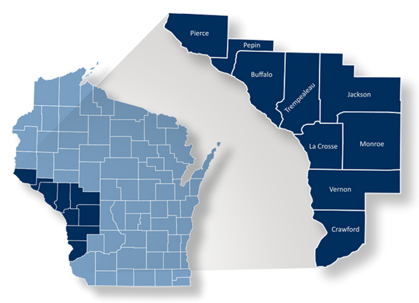
Introduction
The Mississippi River Regional Planning Commission (MRRPC) provides planning and economic development services to improve the environment, economy, and quality of life of the nine-county region in Southwest Wisconsin including Buffalo, Crawford, Jackson, La Crosse, Monroe, Pepin, Pierce, Trempealeau, and Vernon Counties. The RPC boundary covers more than 6,000 square miles and has a population of roughly 317,000. It also has a wide range of prominent job sectors, dominated by manufacturing, agriculture, health care and retail trade. There is an assortment of freight infrastructure to move the region’s products including Interstates and highways, railroads, waterways, pipelines, and airports.
This technical memorandum provides a comprehensive description of the MRRPC’s regional freight system. The multimodal network is essential to the efficient movement of goods and commodities of all modes within and through the region and serves a diverse range of needs by moving goods from interstates and highways and local roads, to intermodal and transload facilities, into rail cars, on to barges, and through pipelines. Not only do these methods of transportation serve the local, state, and regional markets, but the country and international economies as well. This memo also summarizes the condition and performance of the MRRPC freight system and includes a description of project goals and objectives and how they are related to performance metrics and evaluation criteria that will help to quantify and ultimately contribute to freight project recommendations in the region.

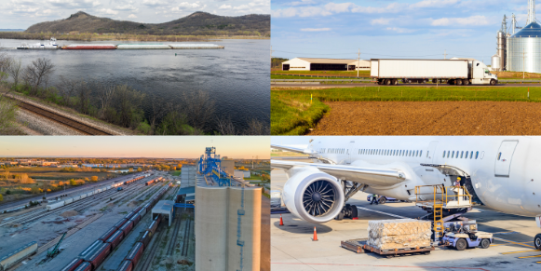
Modal Plans
WisDOT has conducted several recent freight plans and modal studies. Important outcomes from each effort will help to lay the groundwork for the development of the MRRPC Regional Freight Strategy.
Relevant Wisconsin Freight Plans and Modal Studies
Wisconsin State Freight Plan (2018)
2022 Wisconsin Highway-Railway Grade Crossing State Action Plan (2022)
Wisconsin Rail Plan 2030
WisDOT Connect 2050 State Long-Range Plan (2022)
Wisconsin State Airport System Plan 2030 (2015)
Overview of Intermodal Freight in Wisconsin (2019)

Wisconsin State Freight Plan
The existing Wisconsin State Freight Plan (SFP), which was adopted in 2018, provides an in-depth look into the state’s multimodal freight network and how it supports economic, recreational, and personal travel throughout the state.
Figure 1: WisDOT State Freight Plan Goals
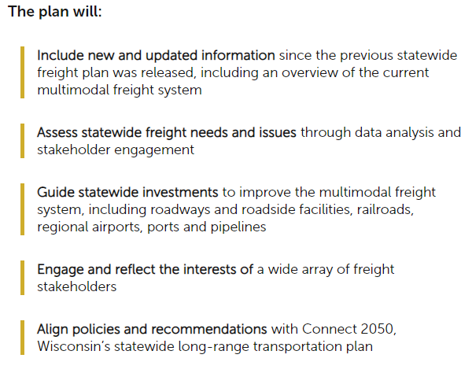
WisDOT is currently in the process of updating the State Freight Plan. The new WisDOT State Freight Plan, expected to be completed in 2022, will integrate freight improvements in future construction projects and prioritize future freight-related projects for funding. These future investments will position Wisconsin to remain competitive in the global marketplace. The Goals of the updated SFP are illustrated in FIGURE 1.

The overall statewide freight flows, by tonnage, from the current SFP are illustrated in FIGURE 2. For additional maps illustrating the tonnage and value of freight flows in western and southwestern Wisconsin, see Appendix A.

Figure 2: Wisconsin Statewide Freight Flows By Mode
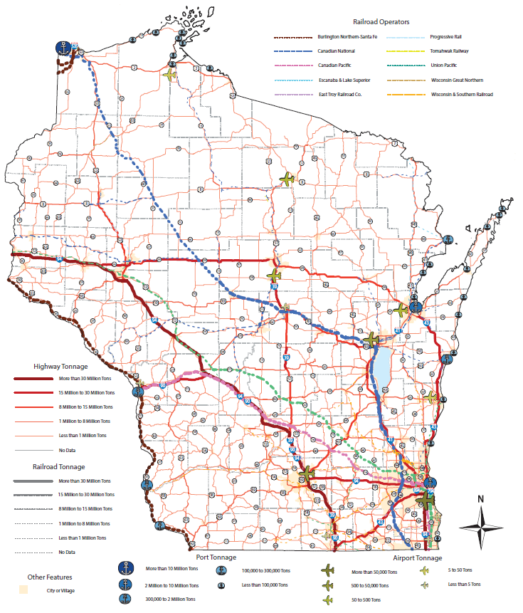

Wisconsin Highway-Railway Grade Crossing State Action Plan
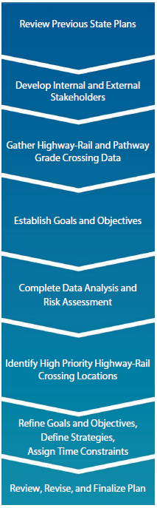
The Wisconsin Highway-Railway Grade Crossing State Action Plan (SAP) was completed in 2022. The SAP is a federally required action plan that describes how the State strives to continuously improve the safety of railroad crossings which cross over public roadways and pathways. Transportation safety is a top priority of the Wisconsin Department of Transportation (WisDOT) and this SAP is consistent with Wisconsin’s existing modal plans. The goals of the SAP are illustrated in Figure 3.
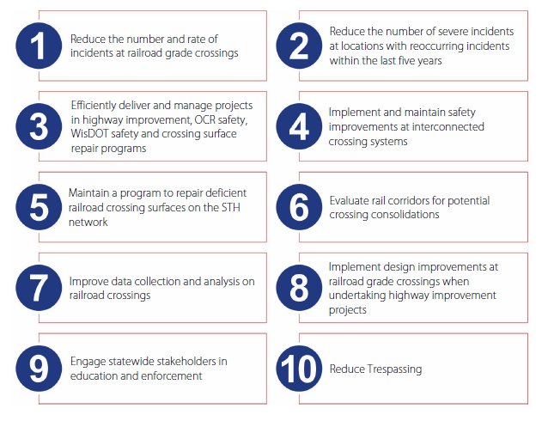
Figure 3: Highway-Railway Grade Crossing SAP Goals

The plan analyzed existing highway-rail and pathway crossing safety incident data throughout the State and nation (see example in Figure 4) and closely collaborated with stakeholders to identify problem locations and used a data-driven process to determine the highest-priority highway-rail and pathway crossings and develop a toolbox of solutions for crossings where focused attention might reduce incidents. The SAP will inform policies and to guide improvement investments and enforcement activities that help ensure safe operations on the state transportation system.
Figure 4: Rail Crossing Incidents In Wisconsin
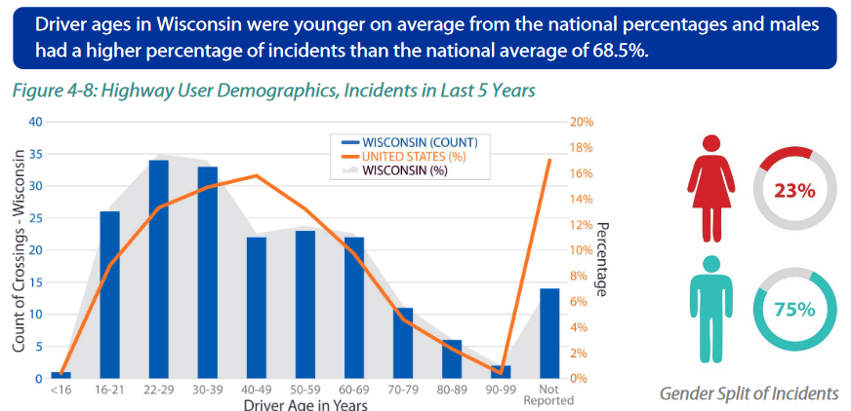

Wisconsin Rail Plan 2030
In addition to the SFP, WisDOT is currently working to update the State Rail Plan. The new plan, expected to be completed in 2023, will build off of the previous Wisconsin Rail Plan 2030, which identifies rail issues that reflect the views of Wisconsin citizens, businesses, and government officials. There are several key parts including a statewide vision for rail movement, service, and facilities. It also serves as a guide for decision-makers through 2030. The purpose of the plan is to:
- Build upon Connections 2030, Wisconsin’s adopted multi-modal long-range plan.
- Meet federal requirements and position Wisconsin to qualify for future federal rail funds
- Present a high-level review of recommendations relative to freight, passenger and commuter rail
- Reflect Wisconsin’s future for passenger rail and more fully develop policies for freight and commuter rail
- Continue state emphasis on supporting economic growth, and improving the state’s competitiveness regionally and globally
- Define a long-range investment program of projects

WisDOT Connect 2050 State Long-Range Plan
The WisDOT Connect 2050 State Long-Range Plan (SLRP) is a statewide, long-term look into the future of Wisconsin’s transportation network, which has goals and a clear path towards how they will be met. It covers all methods of transportation including cars, freight (semi-truck, rail, waterborne), bike/pedestrian, and aviation. It’s visions, goals, and objectives are broad, and they will act as a guide for WisDOT decision-making, and it is meant for all citizens of the state of Wisconsin. To further supplement the attainment of the goals highlighted in the SLRP, a thorough description of technical reports, modal plans, operational plans, business plans, local plans, and programs, will take place and will act as a guide to fulfill the state and federal requirements of the SLRP. 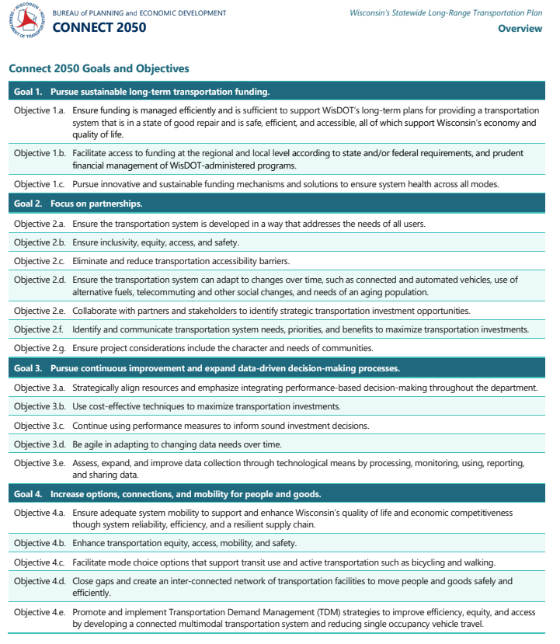
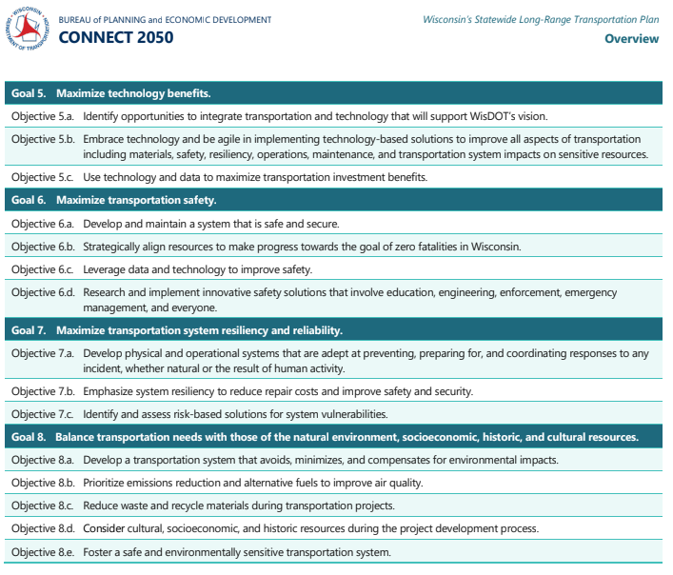

Wisconsin State Airport Plan 2030
The Wisconsin State Airport Plan 2030 completed in 2015 is a comprehensive inventory and overview of Wisconsin’s 98 airports, as well as an implementation plan establishing a set of goals and objectives and how they will be achieved. It is also a component of the Wisconsin Department of Transportation (WisDOT) Bureau of Aeronautics (BOA) continuous aviation system planning process.
The main purpose of the Wisconsin State Airport Plan 2030 is to establish a vision, develop and follow through on goals for the Wisconsin Airport System, and provide a framework for future endeavors pertaining to preservation and enhancement of the airport system.
Plan Objectives:
- Improve safety of Wisconsin airports
- Obtain a current inventory of the facilities and services of each airport in the system
- Establish airport system goals, performance measures and benchmarks
- Identify system and airport specific deficiencies, as well as adequacies and surpluses in the system
- Identify potential overlaps or gaps in the system
- Address the Federal Aviation Administration’s (FAA’s) departure from ground based navigational aids to a satellite-based system and how it will affect Wisconsin
- Develop cost alternatives to meet system goals and benchmarks
- Establish a framework for future investments
System Goals:
- Preserve and maintain Wisconsin’s transportation system
- Promote transportation safety
- Foster Wisconsin’s economic growth
- Provide mobility and transportation choice
- Promote transportation efficiencies
- Preserve Wisconsin’s quality of life
- Promote transportation security
https://wisconsindot.gov/Documents/projects/multimodal/air/sasp3-ch1.pdf

Other Relevant Regional Plans
In addition to the modal plans highlighted above, the MRRPC has conducted several relevant plans and studies. Important outcomes from each study highlighted below have provided the groundwork and shaped the focus for the development of this regional freight strategy.

Community Economic Development Strategy (CEDS)
Since 1976 the County Board of Supervisors of Buffalo, Crawford, Jackson, La Crosse, Monroe, Pepin, Pierce, Trempealeau, and Vernon have cooperated annually to develop the Comprehensive Economic Development Strategy (CEDS) through the MRRPC for the purpose of fostering regional economic development. The CEDS for the Mississippi River Region documents the Region’s conditions, economic challenges, and strategies to improve our Region’s environment, economy, and quality of life. Through the efforts the member counties invest preparing and participating in the development of this report, the nine county Mississippi River Region maintains its Economic Development District designation conferred upon it by the U.S. Department of Commerce-Economic Development Administration (EDA). This district designation qualifies the Region’s counties, communities, institutions, and businesses to be eligible for EDA assistance under its public works and economic development facilities program, technical (research) assistance programs, loan programs, and planning programs. Throughout the years, millions of dollars in Federal EDA grants have funded industrial parks, economic research studies, public facility projects and business loans through this partnership.
The 2022-2027 CEDS provided an in-depth physical, economic, and social analysis of the Region. In 2020, Government, Health Care and Social Assistance, Manufacturing, Retail Trade, and Accommodation and Food Service were the top five industries with the most jobs in the region. Similarly, Utilities, Management of Companies and Enterprises, Information, Mining, Quarrying, and Oil and Gas Ex-traction, and Finance and Insurance were the top five industries with the highest earnings per worker in the region in 2020. Key items from the CEDS that will influence the regional freight strategy are summarized below.
Strengths and Weaknesses
Regional strengths related to freight transportation noted in the document included a strong transportation system and many multimodal access points with available air and rail hubs, barge/port access, and a variety of interstate (I-90 and I-94) and state highway connections. The region has a strong manufacturing base with robust farming and agricultural and forestry industries as important economic drivers. The CEDS notes strong supply chains between existing industries and businesses in the region and an opportunity to develop available land in industrial parks throughout the region. Conversely, there is a recognized lack of transportation alternatives in some areas, a shortage of rural broadband services in the region, and a loss of smaller formerly key industries like logging and dairy farming.
Opportunities and Threats
The CEDS addressed items that are underutilized or could be expanded in the region. Freight related items included applying reserved Federal dollars to develop industry parks due to the closing of coal power plants, expanding alternative energy sources, improved high-speed rail connectivity with upgraded freight rail connections, and expanding the network of stations servicing electric vehicles. Other items identified as threats to the freight system included leftover infrastructure at vacant sand mines and the current condition and funding availability for improvements to the Upper Mississippi River lock and dam network.

MRRPC Freight Strategy Goals and Objectives
This MRRPC Regional Freight Strategy integrates the WisDOT multimodal family of multimodal plans and studies into a cohesive and consistent approach. The project team and TAC employed a deliberate methodology to identify and evaluate the goals from past efforts and develop a unique freight-specific vision and goals for Western Wisconsin that is focused on supporting the Mississippi River RPC’s Comprehensive Economic Development Strategy Goals, Regional Coordinated Transportation Planning goals, Connect 2050 WisDOT Vision, and reflect and incorporate the national multimodal freight policy goals and the national highway freight program goals established in the FAST Act.
Figure 5: Wisconsin Family of Plans
This document identifies policies, strategies, and projects to improve the region’s economic productivity, competitiveness, and quality of life through the movement of goods safely, reliably, and efficiently. These policies, strategies, and projects are developed by evaluating the condition and performance, as well as the trends and issues facing western Wisconsin’s multimodal freight transportation system through data and stakeholder outreach.
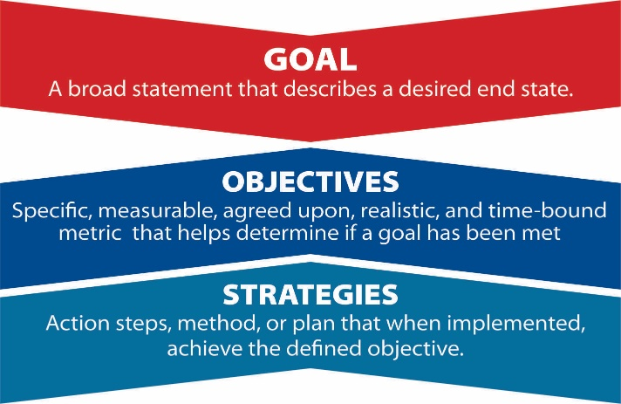
Through this approach, the MRRPC Regional Freight Strategy will advance the economic competitiveness of the region by addressing freight bottlenecks and improving safety, security, efficiency, and resiliency of the network, while minimizing impacts to the natural environment. Ultimately, the project team developed six goals and eleven objectives to guide the development of the Regional Freight Strategy illustrated in Figure 6. Performance measures, related to each goal area identified, are expanded upon in the freight conditions and performance section of this document.

Figure 6: MRRPC Freight Strategy Goals and Objectives
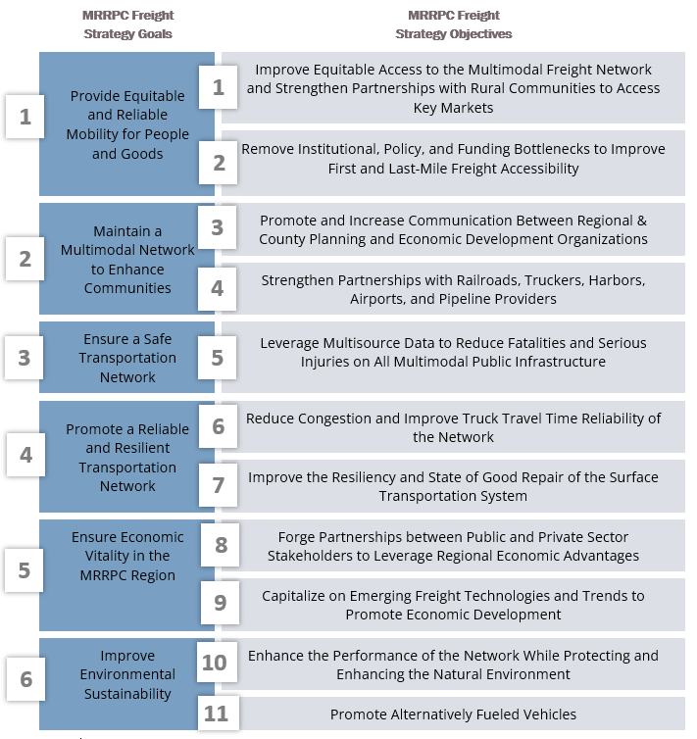

MRRPC Regional Freight Network
Wisconsin’s multimodal freight network is comprised of roadways, railroads, airports, waterways, and pipelines and is essential to the efficient movement of goods and commodities across all modes within the 9-county region and beyond. This section provides a comprehensive inventory and description of the regional freight network and assets, which serve a diverse range of needs by providing for the movement of goods across local, regional, interstate, intrastate, and international multimodal networks. As such it is imperative to understand the characteristics and locations of existing infrastructure throughout the region to assess freight trends, needs, issues, and opportunities.

Highway Network

National Highway System
The National Highway System (NHS) includes a collection of roadways that are critical to the nation’s mobility, economy, and defense and includes subsystems such as interstates, principal arterials, strategic highway network (STRAHNET), and intermodal connectors, among others. The NHS was designated by the USDOT, in cooperation with state DOT’s, metropolitan planning organizations (MPOs), and local officials. The NHS includes the following roadway subsystems:
Interstates: The Interstate Highway System preserves a separate identity within the NHS.
Other Principal Arterials: Highways in rural and urban areas which provide access between an arterial and a major port, airport, public transportation facility, or other intermodal transportation facility.
Strategic Highway Network (STRAHNET): Highways which are important to the United States’ strategic defense policy and which provide defense access, continuity and emergency capabilities for defense purposes.
Major Strategic Highway Network Connectors: Highways which provide access between major military installations and highways which are part of the STRAHNET.
Intermodal Connectors: Highways that provide access between major intermodal facilities and the other four subsystems making up the National Highway System.
MAP-21 Principal Arterials: Highways that provide access between major intermodal facilities and the other four subsystems making up the National Highway System.

A summary of NHS mileage in the MRRPC is included in Table 1.

National Highway Freight Network
The National Highway Freight Network (NHFN), established by the FAST Act, is intended to help state DOT’s strategically direct resources toward improved system performance for efficient movement of freight on highways. The NHFN designated the following subsystems of roadways (see FIGURE 7):
- Primary Highway Freight System (PHFS): This is a network of highways identified as the most critical highway portions of the U.S. freight transportation system. I-94 is the only identified PHFS route in the MRRPC region.
- Other Interstate portions not on the PHFS: These highways consist of the remaining portion of Interstate roads not included in the PHFS. These routes provide important continuity and access to freight transportation facilities.
Subsystem | Mileage
Interstate | 113
Non-Interstate STRAHNET | 9.42
STRAHNET Connector | 7.91
Other NHS | 160
Intermodal Connectors | 2.82
MAP-21 Principal Arterials | 211
Total | 505
- Critical Rural Freight Corridors (CRFCs): These are public roads not in an urbanized area which provide access and connection to the PHFS and the Interstate with other important ports, public transportation facilities, or other intermodal freight facilities. WIS 95 between Hixton and Blair and a small section of USH 53, south of Blair are identified as CRFCs.
Table 1: MRRPC NHS Mileage
Subsystem | Mileage
Primary Highway Freight System (PHFS) Miles | 60
PHFS Intermodal Connectors | 2.8
Interstate Not on the PHFS | 52
Critical Urban Freight Connectors (CUFCs) | 9.21
Critical Rural Freight Connectors (CRFCs) | 21.08
Total | 145.09
- Critical Urban Freight Corridors (CUFCs): These are public roads in urbanized areas which provide access and connection to the PHFS and the Interstate with other ports, public transportation facilities, or other intermodal transportation facilities. The only CUFC is located in La Crosse, along USH 53 and US 14, just south of I-90.

Table 2: MRRPC NHFN Mileage

Figure 7: Regional Highway Freight Network
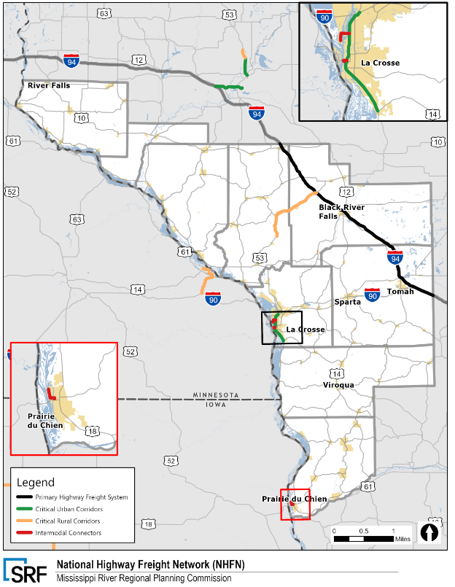

Oversize Overweight Corridors
Wisconsin’s highways support the movement of regular and oversize overweight (OSOW) loads in accordance with state and federal statutes. OSOW loads are trucks whose dimensions and/or weight exceed the legal limits and, with some exceptions, cannot be split into multiple smaller loads. A vehicle that exceeds the legal statutory dimensions usually requires an OSOW permit and must pay associated additional fees to legally travel on designated roadways in the region. Wisconsin oversize and overweight (OSOW) truck routes and high clearance corridors are shown in FIGURE 8.
MRRPC High Clearance Corridors
US 10 from Fairchild to Hastings
WIS 93 from I-94 to Independence
US 53 from Independence to US 12
WIS 21 from Shennington to Sparta
WIS 16 from Sparta to La Crosse
WIS 33 from La Crosse to Cashton

WisDOT has also designated long truck operator corridors (see Figure 9), where the state allows unlimited lengths for the operation of vehicles and combinations of vehicles. Key federal and state long truck corridors in the study area include US 61, US 63, US 12, US 10, US 14, US 53, WIS 27, WIS 93, WIS 33, and WIS 16.
MRRPC OSOW Corridors
I-94 from Oakdale to Hudson
I-90 from Tomah to La Crosse
US 10 from Fairchild to Hastings
US 53 from Galesville to Onalaska
US 14 from Westby to Sylvan
US 61 from Readstown to Easter Rock
US 18 from Prairie du Chien to Bridgeport
US 12 from Fairchild to Black River Falls
WIS 27 from Black River Falls to Westby
WIS 93 from Eleva to Independence

Figure 8: Designated Over Size Overweight and High Clearance Corridors
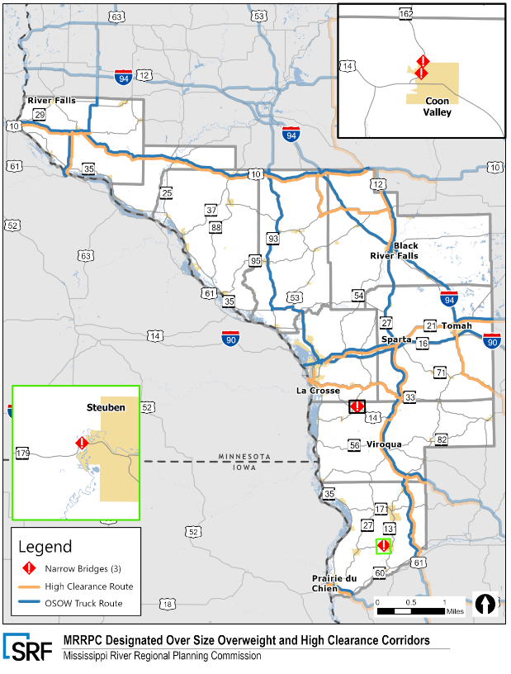
Figure 9: Long Truck Routes
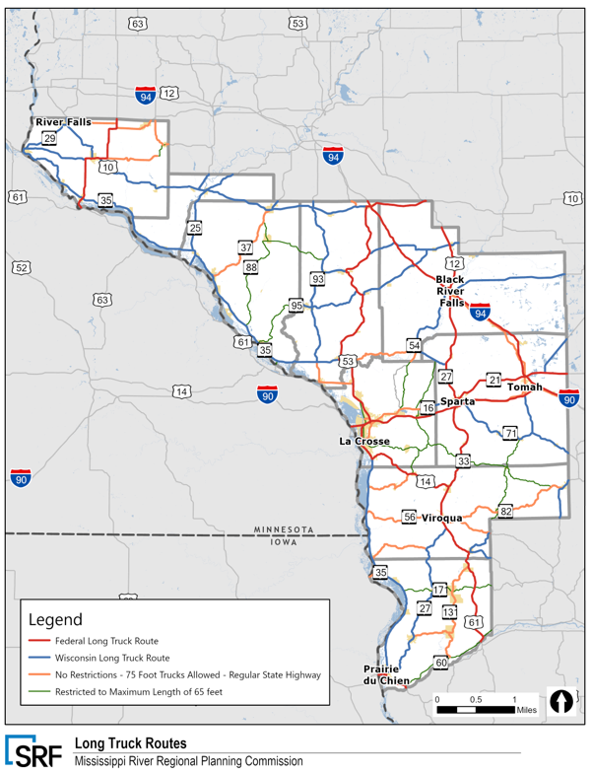

Bridges
Bridges are a critical component of the MRRPC’s multimodal freight transportation network. WisDOT generally defines a bridge as any structure spanning 20 feet or more that carries motor vehicle traffic. Overall, Wisconsin has more than 14,000 bridges spanning state and local roadways. More than 5,000 bridges are along the state highway system (numbered state and federal highways) and are the responsibility of the Wisconsin Department of Transportation (WisDOT). In addition, nearly 9,000 bridges are located along local roadway systems (county and town roads and municipal streets) and are the responsibility of local governments.
Bridges are critical infrastructure assets of the OSOW freight transportation system in western Wisconsin, with more than 679 bridges (see Figure 10) that are maintained by their respective jurisdictional agencies throughout the 9-county region. Bridges provide critical connectivity in western Wisconsin, most notably across the Mississippi River which serves as a substantial natural barrier between Minnesota and Wisconsin. Between St. Paul and Prairie du Chien, this natural divide is especially prominent by dividing the major highway corridors of I-90 and US 10.

Figure 10: Substandard Bridges
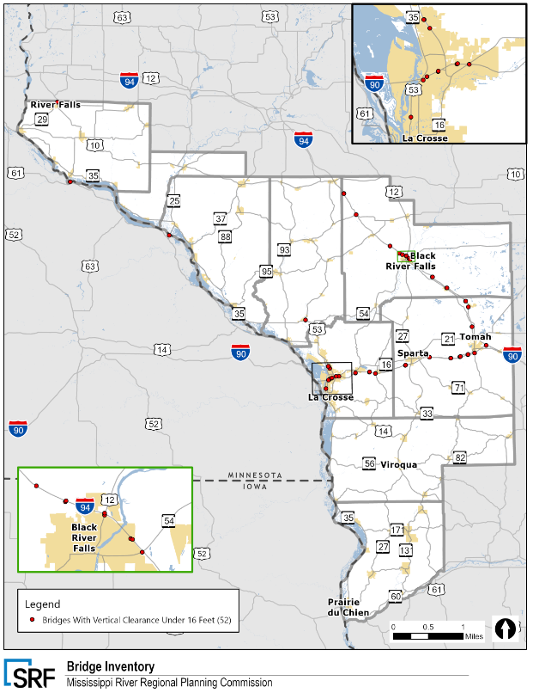

Alternative Fuels Corridors
With the assistance of nominations from state and local officials, the USDOT has established a national network of electric vehicle charging and hydrogen, propane, and natural gas fueling corridors along NHS systems that will help to improve the mobility of alternative fuel vehicles.
FHWA intends to support the expansion of this national network through the following process:
- Provide the opportunity for formal corridor designations on an annual basis;
- Ensure that corridor designations are selected based on criteria that promote the "build out" of a national network;
- Develop national signage and branding to help catalyze applicant and public interest;
- Encourage multi-state and regional cooperation and collaboration; and,
- Bring together a consortium of stakeholders including state agencies, utilities, alternative fuel providers, and car manufacturers to promote and advance alternative fuel corridor designations in conjunction with the Department of Energy.

Designated corridors in western Wisconsin include I-94 and I-90 (see Figure 11). According to the Energy Information Administration (EIA), the 9-county region includes 24 Electric (ELEC), three Liquefied Petroleum Gas (LPG), 13 E85 Ethanol (E85), two Compressed Natural Gas (CNG), three Biodiesel (BD) and one Liquefied Natural Gas (LNG) stations. A majority of these stations are located in close vicinity to La Crosse. In fact, approximately 22 of the total station locations are located in close proximity to La Crosse.

Figure 11: Alternative Fuel Corridors and Stations
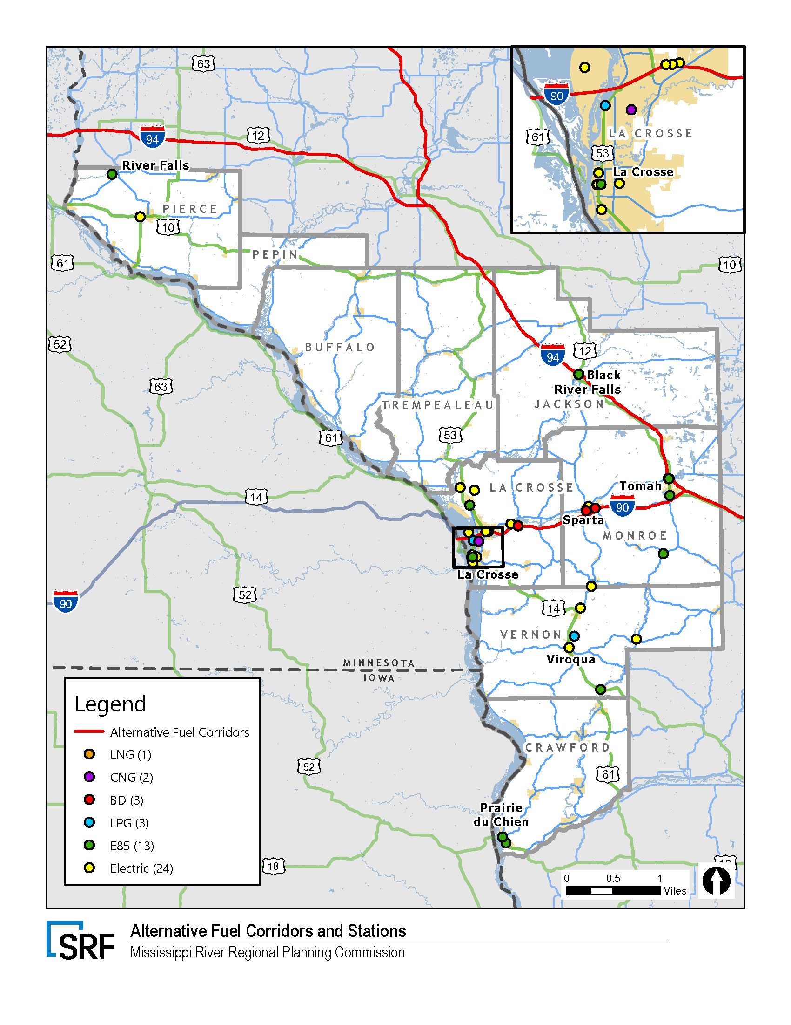

Truck Parking
Figure 12 illustrates the truck parking availability in the MRRPC region. Statewide, there are 30 public rest areas that provide free parking to trucks located adjacent to interstates and state highways. There are five public rest areas that provide truck parking in the MRRPC. Additionally, there are a variety of private truck parking providers such as truck stops and gas stations. Those public rest areas are located in La Crosse, Sparta, and Black River Falls and are all WisDOT operated facilities. They include services such as clean restroom facilities, car and truck parking, road maps and traveler information, and snacks and drinks from vending machines. In December of 2016, WisDOT and a handful of partnering states in the region adopted the Truck Parking Management Systems (TPIMS) to assist commercial truck drivers with truck parking availability. TPIMS use sensors and cameras to create real-time information about the availability of truck parking at the majority of public rest areas. These numbers are then broadcasted on road signs, which can assist commercial truck drivers in planning their rest periods without having to exit the freeway.
WisDOT public rest areas vary in size and a breakdown of parking spaces can be found below:
- I-90 eastbound – La Crosse – Rest Area 31: 16 truck parking stalls
- I-90 westbound – Sparta – Rest Area 16: 16 truck parking stalls
- Black River Falls (2):
  - I-94 westbound – WisDOT Rest Area 53 (Millston): 41 truck parking stalls
  - I-94 westbound - WisDOT Rest Area 54 (Black River Falls): 43 truck parking stalls
In 2014, WisDOT received a $1 million grant from FHWA to pilot a truck parking availability system in the state. The system was deployed in 2016 at four public rest areas on I-94 eastbound from Dunn County to Columbia County. Hybrid Dynamic Message Signs (HDMS) have been installed along the corridor showing truck parking availability information. In 2015, Wisconsin, along with seven other Midwestern states, was awarded a $25 million grant from the United States DOT through the Transportation Investment Generating Economic Recovery (TIGER) program to build a regional truck parking information management system. Wisconsin’s portion of the $25 million grant is $3 million. Using HDMS, this system will include seven public rest areas along the I-94 corridor, east and westbound from the Illinois to Minnesota state lines. This system was constructed between 2016 and 2018. The truck stops in Millston and Black River Falls currently employ this technology.

Figure 12: Truck Parking Availability
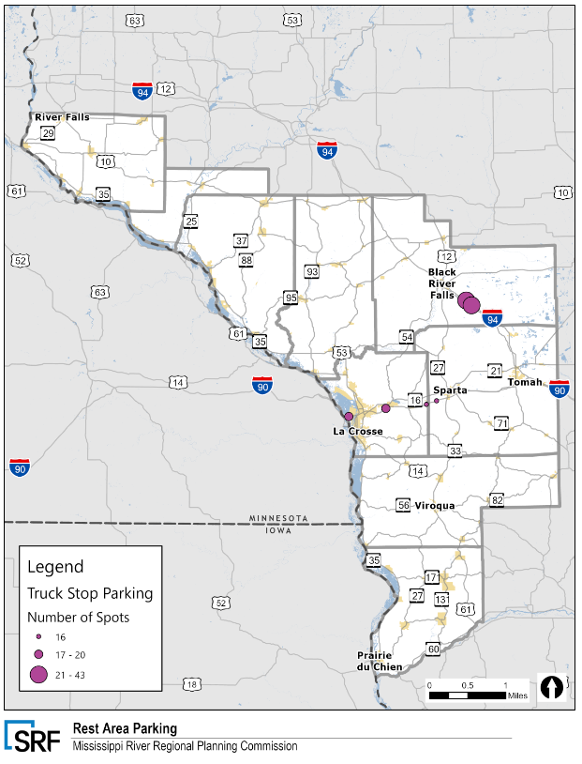

Railroad Network
Wisconsin has more than 3,300 miles of railroad system that make up about two percent of the nation’s rail network. Approximately 403 railroad miles are found within the 9-county MRRPC region, connecting the region to the Minneapolis/St. Paul area to the northwest, ports of Duluth and Superior to the north, and other upper Midwest destinations such as Chicago to the east. The state’s rail system is owned and operated by ten privately-owned freight railroads and the State of Wisconsin. Figure 13 displays the regional rail network and Table 3 provides the mileage for each rail carrier operating in the MRRPC Region.

There are three Class 1 rail carriers with active track in the MRRPC region, including BNSF, Canadian National, Canadian Pacific, and Union Pacific. In addition, the Wisconsin and Southern railroad is located along the southern boundary of Crawford County.
Table 3: MRRPC Rail Mileage
Subsystem Ownership | Mileage
BNSF | 173
Canadian National | 88
Canadian Pacific | 53
Union Pacific | 68
Wisconsin & Southern RR | 21
Total | 403

Figure 13: Rail Network
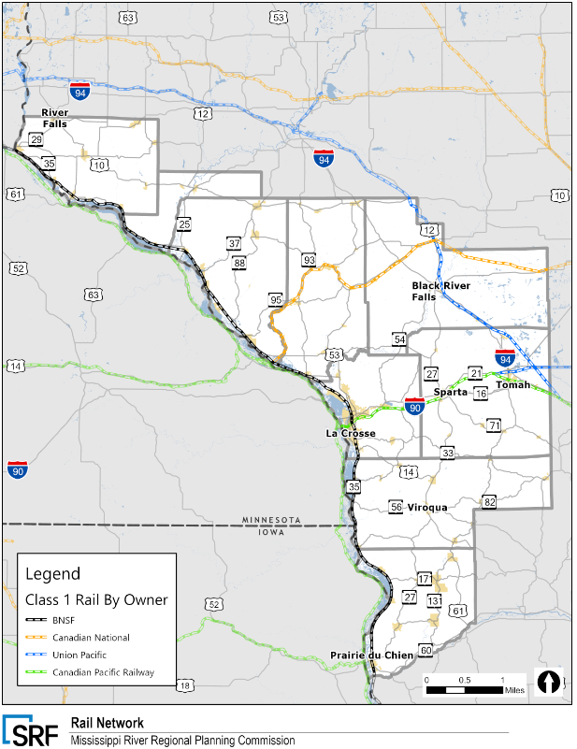

Figure 14: Public At-Grade Railroad Crossings
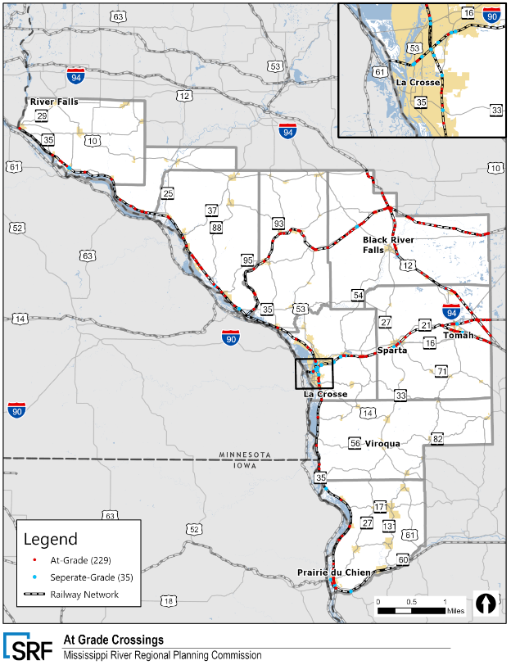

Waterway Network
The MRRPC Region is strongly connected to the Mississippi River. The M-35 Marine Highway Route runs from Lock/Mile 1 on the Mississippi River in Minneapolis, MN to the confluence of the Mississippi and Illinois Rivers in Grafton, Illinois, where the M-55 Route begins. Together, the M-35 and M-55 provide an all-water route from the beginning of the Mississippi River to the Gulf of Mexico. The M-35 is a major hub for freight tonnage transported by truck to some of the region’s major metropolitan areas such as Minneapolis-St. Paul, MN, Chicago, IL, and St. Louis, MO. By 2040, the US DOT predicts that several major highway segments (e.g., I-70 in Missouri, I-80 in Iowa, and I-90 and I-94 from Chicago to Minneapolis) will experience more recurring peak-period congestion and high-volume truck segments on the National Highway System that carry more than 8,500 trucks per day. Water transportation is an important part of the Upper Mississippi River region's freight network. The M-35 promotes domestic and international trade by establishing a strong link
and other connections to the Gulf of Mexico. For example, in 2011, approximately 61.2 million short tons of cargo were transported on the M-35, compared to 60.7 million tons in
2010 (domestic and foreign). The states along the M-35 use the Upper Mississippi River to ship commodities to as many as 15 adjacent or nearby states.
According to the State Freight Plan, there are 29 commercial ports in Wisconsin. Two of them are in the MRRPC Region and are illustrated in Figure 15. The Port of La Crosse is located between the Town of Onalaska and La Crosse and handles nearly one million tons of inbound and outbound liquids, cement, grain, and general bulk products by barge annually on the Upper Mississippi River. The port of Prairie du Chien is located north of Prairie du Chien, Wisconsin. The docks and storage facilities that handle bulk cargo at the port are privately owned. The city owns docks that accommodate large paddle wheel cruise boats and small excursion boats. Port facilities in Prairie du Chien handle 600,000 tons per year of bulk commodities, including coal, salt, sand, cement, grains, and fertilizer. Rail service is provided by BNSF and Wisconsin & Southern Railroad. Of Wisconsin’s Major Commercial Ports, the Port of Prairie Du Chien ranked 5/8 in terms of most cargo shipped.
In March 2022, six Wisconsin harbor projects received a total of $9.4 million in federal funding from the Harbor Assistance Program and La Crosse’s Hanke Terminal is one of them. $2 million will be used to construct an agricultural commodity trans-loading facility. The funds will directly pay for a bulkhead fill to create a solid pier with dock walls and pile clusters. Wisconsin’s Harbor Assistance Program (HAP) was established in 1979 and helps harbor communities maintain and improve waterborne commerce and create employment opportunities. The US Army Corps of Engineers (USACE) is currently updating its strategic land use and recreation management Master Plan that will serve as the vision for the river and the Corps’ management policies.
Figure 15: Waterway Network
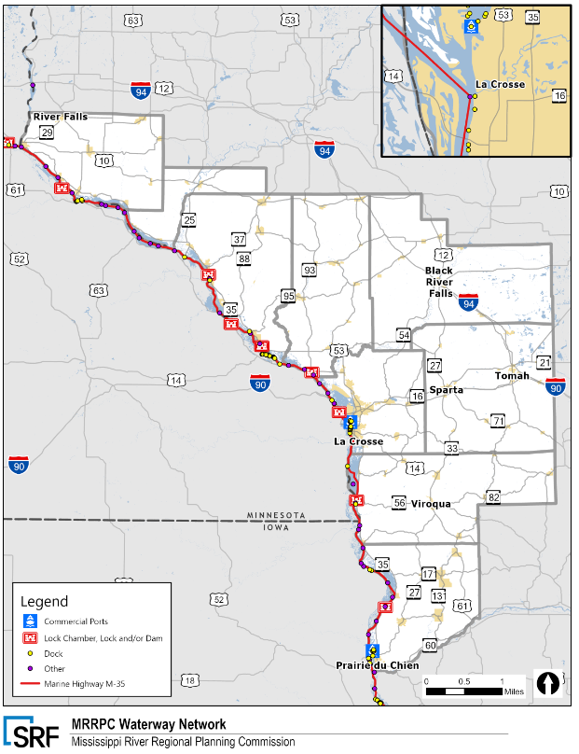

Aviation Network
Wisconsin’s aviation network plays an important role in the state’s economy from an employment, recreational, and transportation perspective. However, the aviation network and air cargo shipments make up a very small percent of the freight mode share in Wisconsin as well as the MRRPC. There are 97 airports in the State Airport System, of those, seven are found in the MRRPC region and a map can be viewed in Figure 16.
Wisconsin Airports are classified according to the following categories:
Commercial Service Airports are publicly owned airports that have at least 2,500 passenger boardings each calendar year and receive scheduled passenger service. Passenger boardings refer to revenue passenger boardings on an aircraft in service in air commerce whether or not in scheduled service. The definition also includes passengers who continue on an aircraft in international flight that stops at an airport in any of the 50 States for a non-traffic purpose, such as refueling or aircraft maintenance rather than passenger activity. Passenger boardings at airports that receive scheduled passenger service are also referred to as Enplanements.
General Aviation Airports are public-use airports that do not have scheduled service or have less than 2,500 annual passenger boardings (49 USC 47102(8)). Approximately 88 percent of airports included in the NPIAS are general aviation.

Wisconsin has a total of eight commercial service airports. Seen in Figure 16, La Crosse Regional Airport is the only commercial service airport found in the MRRPC region. It is served by Delta and American Airlines and flies non-stop to Minneapolis and Chicago three times daily. In calendar year 2020, La Crosse Regional Airport had only 44,050 passengers, down 54 percent from the previous year of 97,069. This can likely be attributed to the COVID-19 pandemic, as calendar year 2018 also had 99,651 passengers. In addition to providing commercial service, the La Crosse Regional Airport is also home to Colgan Air Services, a fixed base operator (FBO) that provides services such as in line servicing (re-fueling, temporary plane storage), aircraft maintenance, and aircraft management. Colgan Air Services also operates a ground school and flight instruction. La Crosse Regional Airport does not host air cargo operations.

Figure 16: Aviation Infrastructure
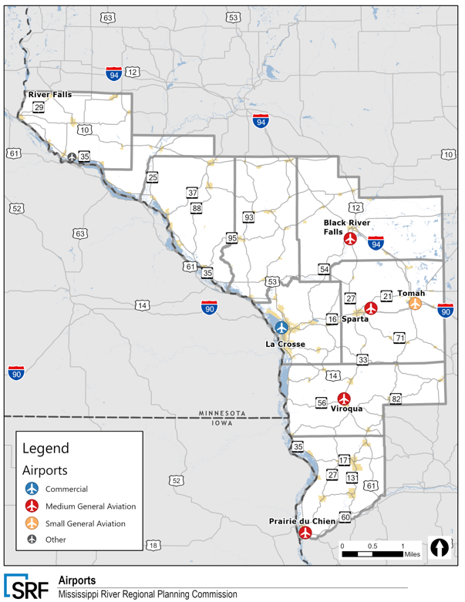

Pipeline Network
Pipeline transportation allows for low-cost movement of liquids and gases to designated areas for consumption. The MRRPC region does not have any active gas pipelines, but it does host the Flint Hills Resources oil pipelines, which transports crude oil, refined petroleum products, chemicals, and natural gas liquids. The pipeline is located in the northern parts of Pierce and Pepin County’s. Flint Hills Resources is the sole owner of the pipeline.
The National Pipeline Mapping System (NPMS) contains hazardous liquid and gas transmission pipelines. The gas transmission and hazardous liquid mileage is illustrated in FIGURE 17. This summary of mileage by county includes all pipelines in the NPMS categorized as active
In the MRRPC region, active gas transmission pipelines are found in all nine counties, however, hazardous liquid pipelines are only found in Pierce and Pepin counties. Overall, Pierce County has the highest concentration of pipeline miles with nearly 145 total miles. Wisconsin has no crude oil production or reserves, however, the southwestern part of the state along the Mississippi River contains high quality sand used in other states to enhance crude oil and natural gas recovery by hydraulic fracking. The state’s only oil refinery is located in Superior, Wisconsin, but that closed in April 2018 after an explosion. It is due to reopen in 2023 and will deliver crude oil via pipeline from Canada and North Dakota and the Chicago region.

Figure 17: Pipeline Network
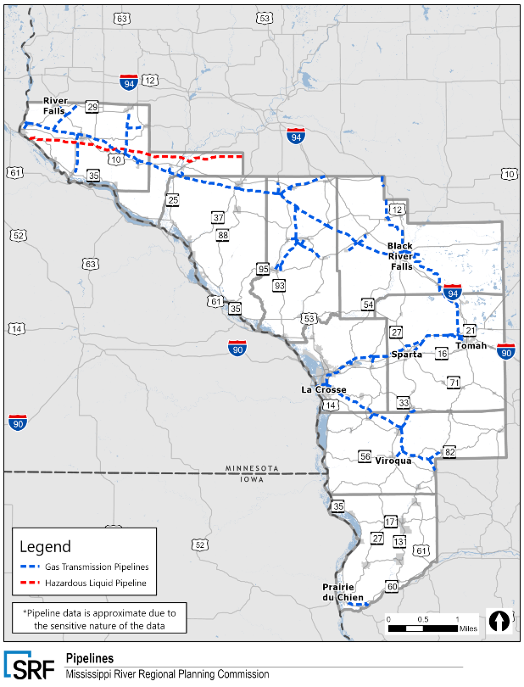

MRRPC Regional Freight Facilities
Consistent with the Wisconsin Statewide Transportation Plan, the Wisconsin Department of Transportation (WisDOT) explored ways to identify major regional freight facilities in the nine county MRRPC region. A freight intensive area is a cluster or group of freight facilities that generates, distributes, or attracts large amounts of freight activities and has a significant impact on the MRRPC region and Wisconsin’s transportation system and economy.
Major freight and freight related industries have been analyzed in this section by looking at their contribution to the state’s Gross Domestic Product (GDP), the number of freight related establishments, and number of employees. Table 4 illustrates the region’s top 15 employers. Employers with the same business name and address have been aggregated. Freight intensive industries including construction, manufacturing, wholesale and retail trade, transportation warehousing, and health services have significant contributions to the region’s GDP.
Table 4: MRRPC Top 15 Employers
Business Name | Location | Employees
Gundersen Lutheran Administrative Services Inc. | La Crosse | 14,715
Ashley Furniture Industries, LLC | Arcadia | 9,678
Mayo Clinic Health System-Franciscan Medical Center, Inc. | La Crosse | 6,112
Kwik Trip, Inc. | La Crosse | 4,000
Marten Transport, Ltd. | Mondovi | 1,878
Viterbo University, Inc. | La Crosse | 1,359
The Trane Company | La Crosse | 1,216
Optumserve Health Services, Inc. | La Crosse | 851
University of Wisconsin System | River Falls | 800
Veterans Health Administration | Tomah | 750
Millis Transfer, Inc. | Black River Falls | 700
Truvant North America LLC | Prairie Du Chien | 608
The Joseph Bethany-St. Corp | La Crosse | 520
Hanover Direct Operating Group | La Crosse | 450
Western Technical College | La Crosse | 400

Intermodal Terminals
There are three intermodal terminals located in or just outside the MRRPC region, as illustrated in Figure 18. One of them, the Ashley Furniture private rail terminal, is located in the MRRPC study area and receives more than 13,000 containers annually. The Ashley Furniture terminal is served entirely by Ashley Distribution Services and no other trucking companies are allowed into the terminal. The terminal handles containers from the CN Arcadia sub destined for California that are interchanged to BNSF in Chicago. For containers on the CN Arcadia sub that are destined to the west coast ports of Portland, Seattle, Vancouver, and Prince Rupert, containers are interchanged to the BNSF Winona sub.
Two additional intermodal terminals in New Richmond and Chippewa Falls are located just outside of the study area but have major influence on how goods are transported in and through the MRRPC region. Canadian National opened its New Richmond intermodal terminal in 2021 to provide direct CN Intermodal container service to the Twin Cities market. The new service provides customers in the RPC region and with an alternative shipping option. The New Richmond terminal links shippers to CN’s far-reaching three-coast network and serves a range of import and export industries including automotive and finished consumer goods, grain, soybean, as well as forest products. CN opened its Chippewa Falls intermodal terminal in 2012 and operates twice a week container services on the 8.5 acre yard including a grain transfer facility.

Figure 18: Intermodal and Regional Freight Facilities
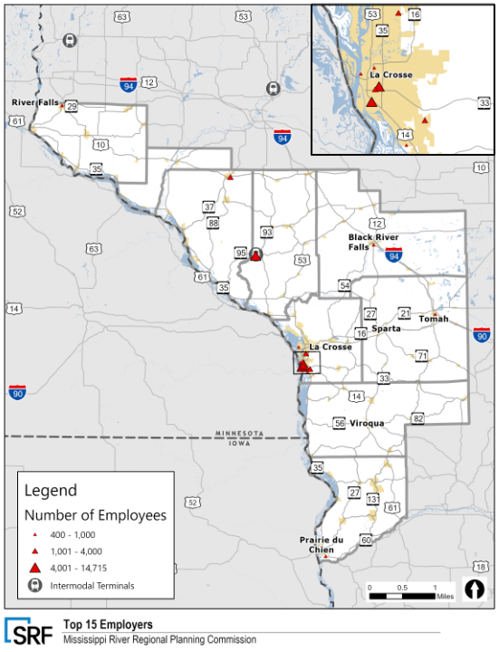

MRRPC Regional Freight Flows
A summary of the tonnage and value of freight transported in the MRRPC region by truck, rail, water, and air is summarized below. The information is developed based on data provided from the Transearch freight database and include commodity flows by origin, destination, commodity, and transportation mode that are destined for western Wisconsin or produced in western Wisconsin and destined for another county, state, or country.
In total, over 69 million tons of freight were moved to or from western Wisconsin in 2019. The value of those 69 million tons of freight transported in the western Wisconsin region is estimated at over $21 billion. The graphics on the following page illustrate the multimodal distribution flows in the region. Trucks carried a majority of the tonnage and value of goods in the region, with nearly 71 percent of the total tonnage and 81 percent of the total value. Water was the next most utilized mode with 2.1 million tons of goods shipped annually and just over $1 billion. Freight shipped by air accounts for a small portion of the freight carried by other modes. However, air freight is still important to the economy as the cargo carried by air is typically high value and time sensitive.
According to 2019 IHS Transearch data, Monroe County and Trempealeau County were the highest origins of outbound rail shipments by tons at 7,425,114 (23 percent of statewide total) and 4,733,473 (15 percent of statewide total); respectively. The top commodities transported into the region by weight included farm products, nonmetallic minerals (sand/rock/gravel), food or kindred products, petroleum and coal products, secondary traffic (primarily commodities moving from warehouse/distribution centers to retail locations), and clay, concrete, glass, and stone. The industrial sand sector in Wisconsin has been through multiple significant fluctuations in demand over the past decade. The primary product, Northern White silica, was once in high demand as a proppant for the fracking process in shale oil fields across North America. Destinations included North Dakota, Pennsylvania, and Texas, with unit trains supplying regular deliveries. By 2012, 80 mines were either operating or planned. By 2017, drillers noted two key findings that reduced demand for Wisconsin sand. First, shale oil wells generally have short lifespans. Second, local brown sand from the West Texas Permian Basin could perform adequately, at a far lower cost. As companies opened sand plants in Texas, Wisconsin plants closed. As of September 2020, about 12 Wisconsin mines remained active, down from 69 in 2016. The top commodities transported into the region by value included farm products, nonmetallic minerals (sand/rock/gravel), food or kindred products, petroleum and coal products, secondary traffic (primarily commodities moving from warehouse/distribution centers to retail locations), and clay, concrete, glass, and stone.
According to the most recent data, the top commodities transported out of the region by weight included farm products, nonmetallic minerals (sand/rock/gravel), food or kindred products, petroleum and coal products, secondary traffic (primarily commodities moving from warehouse/distribution centers to retail locations), and clay, concrete, glass, and stone. It should be noted that sand/rock/gravel commodity may be overrepresented based on our current understanding of the frac mining industry and the dynamics of sourcing clean white sands from Wisconsin with sands from other regions in Texas and beyond. The top commodities transported out of the region by value included farm products, nonmetallic minerals (sand/rock/gravel), food or kindred products, petroleum and coal products, secondary traffic (primarily commodities moving from warehouse/distribution centers to retail locations), and clay, concrete, glass, and stone.
Figure 19 illustrates freight flows in the region in 2022. According to the data, freight flows are heaviest on the region’s interstate routes and major connector routes. WIS 16 between Sparta and La Crosse is the highest volume freight corridor not on an interstate. US 53, WIS 95, WIS 27 are also key regional freight routes according to the FAF 2022 flows.
Table 5: Regional Freight Flows by Mode, 2019
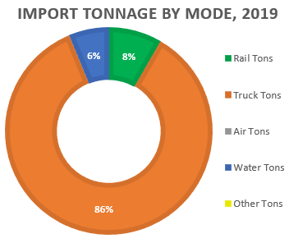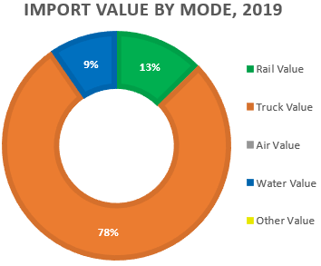

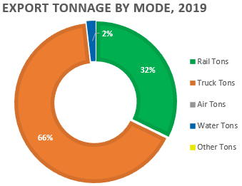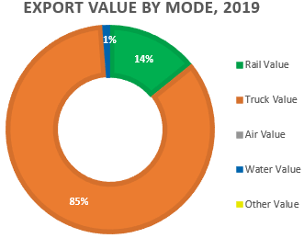

Figure 19: Freight Analysis Framework (FAF5) Highway Freight Flows (2022)
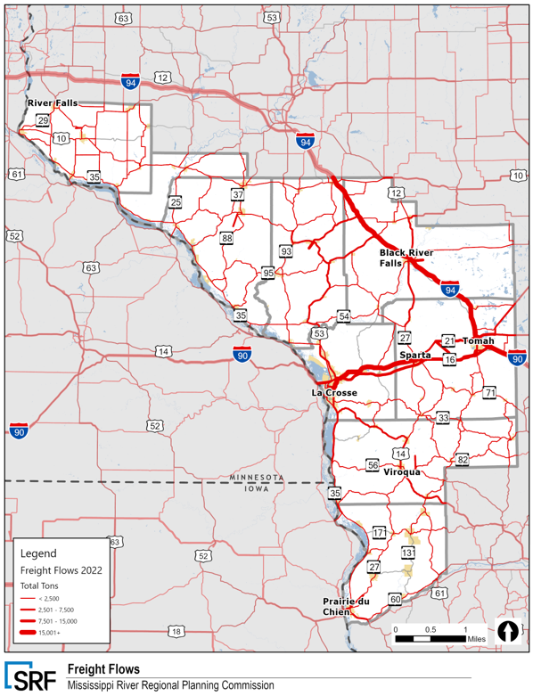
The MRRPC has a strong connection to the upper Mississippi river and utilizes the important marine highway to transport many of the bulk commodities produced in the region. Figure 20 and Figure 21 illustrate waterway flows moving up and down the Mississippi River. According to the US Army Corps of Engineers there was approximately 4.7 million tons of bulk goods being transported up the river through Priarie du Chien and to La Crosse. The commodities destined to the Twin Cities by water decrease significantly north of the La Crosse area. Similarly, current data shows that tonnages of bulk goods shipped on the Mississippi increase in volume south of La Crosse area ports.
Railroads transported 25 percent of the goods by tonnage and 13 percent by value in 2019, respectively. Projected rail tonnage in the region is illustrated in Figure 22.

Figure 20: Waterway Freight Flows Upriver
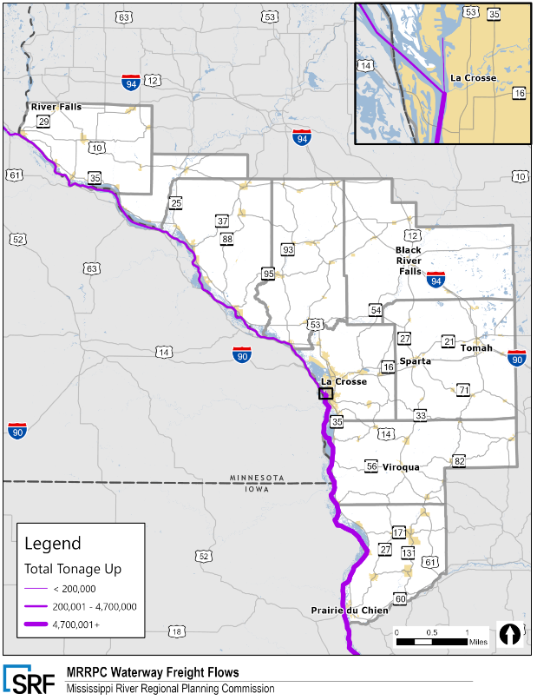

Figure 21: Waterway Freight Flows Down River
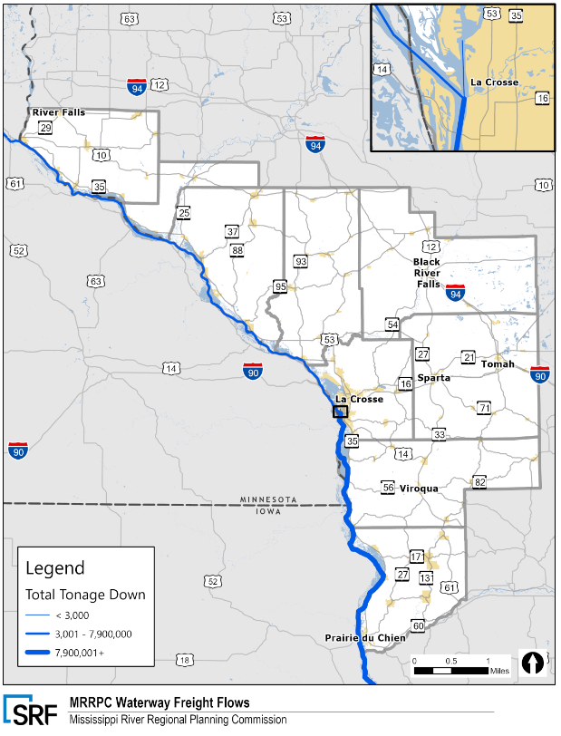

Figure 22: Future Rail Flows in Wisconsin
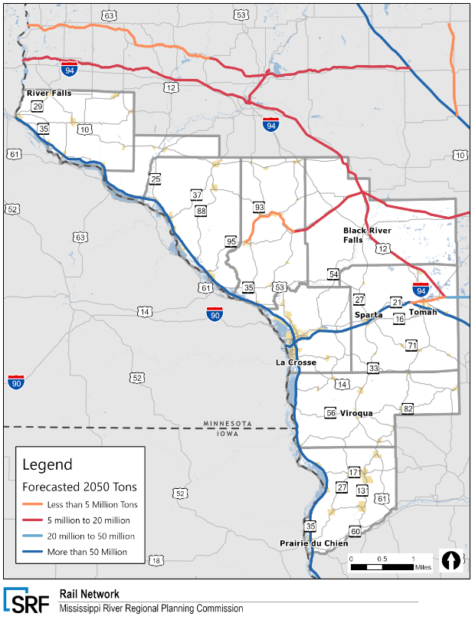
Source: 2017 IHS Transearch with 2050 Forecast

MRRPC Freight Network Condition and Performance
The condition and performance of the MRRPC’s freight transportation systems are described in previous sections. The performance measures included in this document are consistent with WisDOT Statewide Transportation Improvement Program (STIP), Wisconsin Transportation Asset Management Plan (TAMP), Transportation Performance Management (TPM) federal performance measures, Wisconsin 2050 Vision goals, Wisconsin State Freight Plan objectives and the Highway Performance Monitoring System (HPMS). These measures indicate whether the MRRPC’s multimodal transportation system is achieving the objectives outlined in this plan and also show whether progress is being made towards federal and organizational goals. Additionally, performance measures required by FHWA, such as bridge and pavement conditions are also summarized.
This technical memorandum evaluates and documents the condition and performance of the MRRPC region’s freight transportation systems and assets described earlier in this memo. WisDOT has embraced a “data-driven” asset management approach to achieve the goals for projects and programs. The data-driven project development approach used for this Regional Freight Strategy identifies condition, needs, and priorities of the MRRPC Regional Freight Highway Network.

Freight Network Condition
The FHWA has defined a range of inspection values to determine performance of an individual pavement is rated “good”, “fair” or “poor”. If all three conditions factors for a given pavement are “good”, based on the latest inspection, FHWA rates the pavement as “good”. If two or more of the condition factors are “poor”, the pavement is rated as “poor”. Pavements not falling into either of these categories are rated “fair”. Figure 23 illustrates the pavement condition in the region. Pavements in the southern half of the MRRPC region along WIS 60, WIS 82, and WIS 131 rated poorly. There is a long stretch of WIS 95 from Fountain City to Hixton with poor pavement condition and current freight flow data shows heavy truck flows on WIS 95 from Blair to Hixton, which is an important east-west regional freight connector.

Figure 23: Pavement Condition Index (2022)
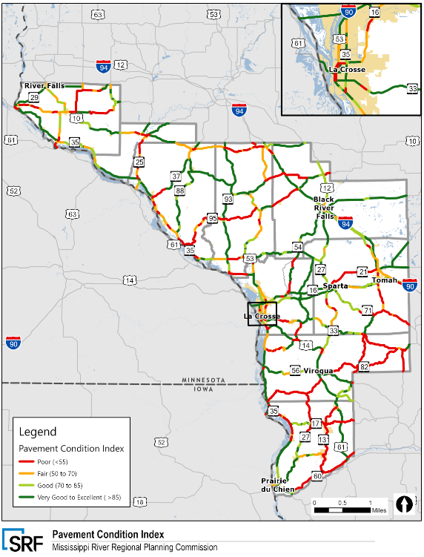
Bridge performance (not including culverts counted as bridges) is classified as “good”, “fair” or “poor” based on the lowest NBI rating for FHWA’s three bridge condition factors. If the lowest rating among the three factors is a 7, 8 or 9, the bridge is rated as “good”. If the lowest rating is a 5 or 6, the bridge is rated as “fair”. If the lowest rating among the three condition factors is less than 5, the bridge is rated as “poor”. Culverts counted as bridges are classified as “good”, “fair” or “poor” based on the NBI rating factor for culvert condition using the same logic. A rating of 7, 8 or 9 means the culvert is classified as “good”, and a rating less than 5 means the culvert is classified as “poor”, with “fair” falling between these two extremes.
Functionally obsolete means that the bridge design is outdated. For example, narrow shoulders, narrow lanes, or older traffic barriers can induce functionally obsolete classification. Functionally obsolete bridges are scheduled for replacement or rehabilitation as budgets permit. Structurally deficient means that a National Bridge Inspection (NBI) structural condition state is poor, or worse. Structurally deficient bridges are recommended for repair, or scheduled for replacement; meanwhile, they are posted as necessary for load, or closed. Figure 24 depicts all structurally deficient and functionally obsolete bridges in Wisconsin. According to the American Road and Transportation Builders Association (ARTBA) in the 2020 Bridge Inventory annual report, there are 987 structurally deficient bridges in Wisconsin and 278 of them are located in Congressional District 3, which has a similar footprint to the MRRPC region. There is one bridge on WIS 162 that is currently rated in serious condition just north of Coon Valley, Wisconsin.

Figure 24: Functionally Obsolete and Structurally Deficient Bridges
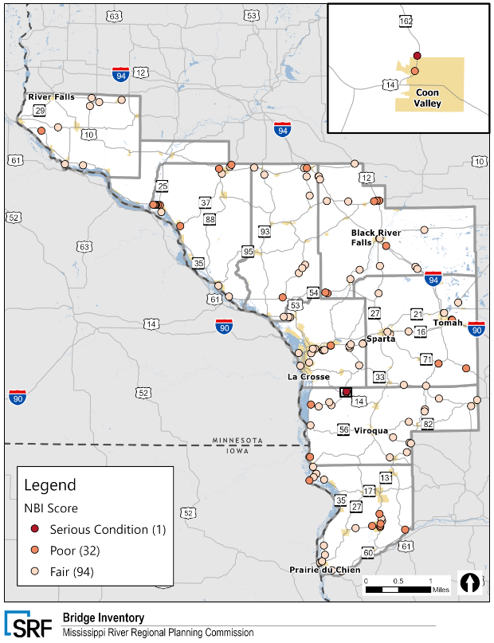

MRRPC Freight Network Performance
The MRRPC Regional Freight Strategy includes an evaluation of established performance measures to assess the performance of the regional freight network. The focus of the analysis is driven by the data that is available to evaluate system performance. The performance measures considered in this plan are consistent with WisDOT’s Transportation Asset Management Plan (TAMP), Transportation Performance Management (TPM) federal performance measures, SFP goals and objectives and the Highway Performance Monitoring System (HPMS). These measures indicate whether MRRPC’s transportation system is achieving the objectives outlined in this plan and also show whether progress is being made towards federal and organizational goals.
Strengths and/or weaknesses discovered during performance measure analysis can assist in the identification of specific needs or other transportation issues. This process supports the project identification and development phase to construct the freight project needs list. Therefore, performance measures analysis can be used as a guide for decision-making in freight-related transportation investments. For example, proposed highway rail-grade crossing projects, truck parking projects, and highway improvement projects all have different criteria that should be assessed using the applicable performance measures. Table 6 depicts performance measures and criteria that have been proposed to assess highway freight improvement projects in future phases of this regional freight strategy.
Table 6: MRRPC Freight Strategy Performance Measures
Freight Strategy Goal | Proposed Freight Strategy Measures
Provide Equitable and Reliable Mobility for People and Goods | AADTT
 | Poor Pavement Conditions
 | Proximity to Intermodal Hubs
 | Roadways within Freight Intensive Areas
Maintain a Multimodal Network to Enhance Communities | Bridge Condition
 | Roadways with Top Freight Bottlenecks
 | Bridge Weight Restrictions
 | Bridge Clearance Restrictions
Ensure A Safe Transportation Network | Rail Crossing Incidents
 | Truck Injuries/Fatalities Frequency
Promote a Reliable and Resilient Transportation Network | Presence of Poor Pavement Conditions
 | Presence of Structurally Deficient Bridges
Ensure Economic Vitality in the MRRPC Region | # of Jobs Created
Improve Environmental Sustainability | On Designated Alternative Fuels Corridor
 | Number of Alternative Fueling Stations Within 1 Mile

The process of identifying, evaluating, and ranking needs, capturing unaddressed needs (referred to as gaps), and prioritizing opportunities (high-ranking gaps) for potential project concepts will occur over five steps and will be documented in Technical Memorandum 2.
- Map needs
- Map planned projects
- Identify gaps or where needs and programmed projects do not overlap
- Review qualitative information to ensure proper prioritization
- Quantitatively rank gaps using measures to identify opportunities

The following sections will summarize key data that has been collected and will be used to evaluate and prioritize potential project needs and opportunities.
Figure 25 illustrates estimated annual average daily truck traffic on the region’s roads in 2021. Interstates in the region were the roadways with the highest truck volumes, with segments of I-90 near Oakdale and I-94 from Tomah to Osseo also showing the highest volume of trucks in the region.
Figure 25: Annual Average Daily Truck Traffic
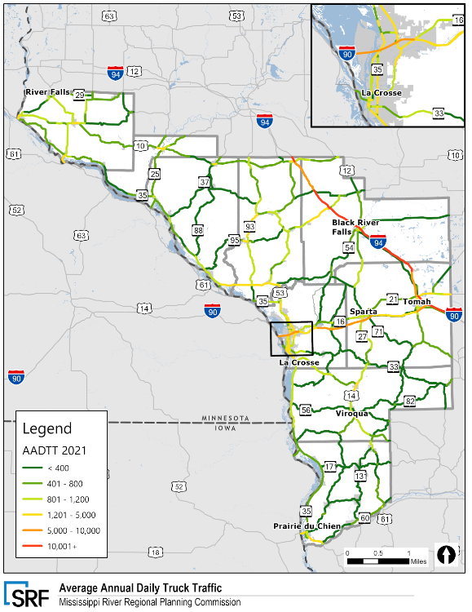

Truck Travel Time Reliability
Truck travel time reliability (TTTR) measures the consistency of travel along a corridor by comparing the 50th percentile and 95th percentile speeds along a segment of roadway. The Federal Highway Administration (FHWA) has defined an index of 1.5 as the acceptable threshold for truck mobility, with higher values representing potential freight bottlenecks.
TTTR was provided by WisDOT and covers the NHS and other major roadways in the state. Overall, most roadway segments operate acceptably (less than an index of 1.5) or with limited reliability issues. Figure 26 illustrates the truck travel time reliability for the MRRPC region during weekday peak hours from 4 pm to 8 pm. MRRPC roadway segments with high TTTR indices are mostly focused in urban areas, at signalized intersections and major junctions, and along the following high-volume corridors:
Other areas with minor reliability issues include connectors to I-90 and I-94 in La Crosse, Sparta and Tomah and segments of that carry higher volumes and/or travel through more urban areas like Black River Falls and Durand. The TTTR data shows that during the weekday evening peak hours truck trips towards key regional destinations like Chicago or Eau Claire can become unreliable on key freight segments such as WIS 16 northeast of La Crosse and WIS 21 near Fort McCoy. This unreliable freight connector is also identified as a heavy freight corridor according to the FAF data.
I-90 from La Crosse to Tomah
I-94 from Tomah to Eau Claire
WIS 21 from Tomah to Sparta

Figure 26: Truck Travel Time Reliability (TTTR)
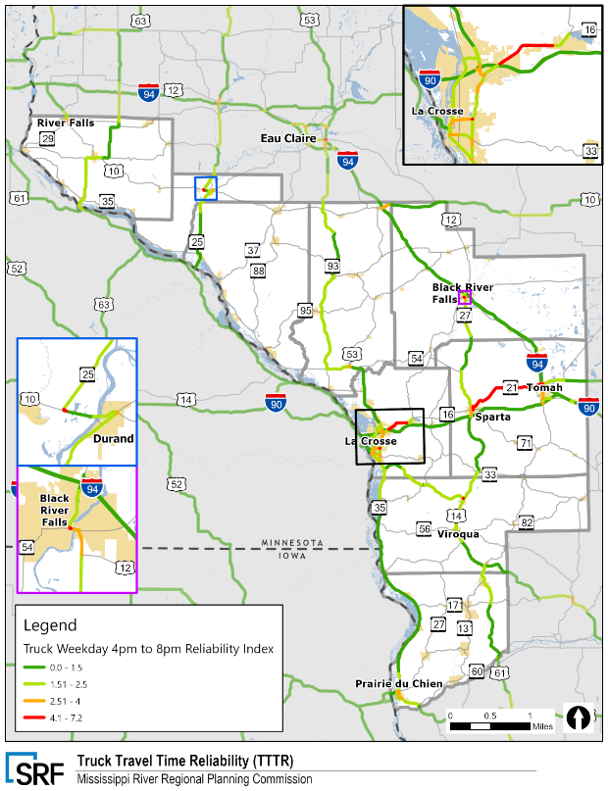

Highway (Truck) Safety
Crash hot spots were identified using nearly nine years of crash data from 2011 to 2020. Vehicle categories commercial truck crashes that resulted in an injury or fatality and were not deer related. This methodology ensured that freight-involved crashes along higher volume freight corridors were the focus of study.
From 2011 to 2020, approximately 12,650 truck crashes occurred on roadways in the RPC, with 98 of the crashes resulting in fatalities. Since 2011, there has been a variable fluctuation in the amount of traffic crashes involving a truck on regional roadways. In 2020, the number of truck crashes decreased by 26 percent, or 363 accidents, from 2019.
La Crosse County had the most truck crashes (330) but saw a 33 percent decrease in total truck crashes from 2019 to 2020. Pepin County had the fewest total truck crashes (15) in 2020. Figure 27 illustrates the areas in western Wisconsin with the highest concentration of truck crashes. The La Crosse metropolitan area has a higher occurrence of truck crashes. Urban areas along major Interstates like Black River Falls, Sparta, and Tomah have more occurrences of truck crashes than rural areas. According to statewide data, every County in the MRRPC has experienced a decrease of their overall truck crashes from 2019 to 2020. However, the total number of truck crash fatalities increased from seven to eleven crashes from 2019 to 2020.

Figure 27: Truck Crash Hot Spots
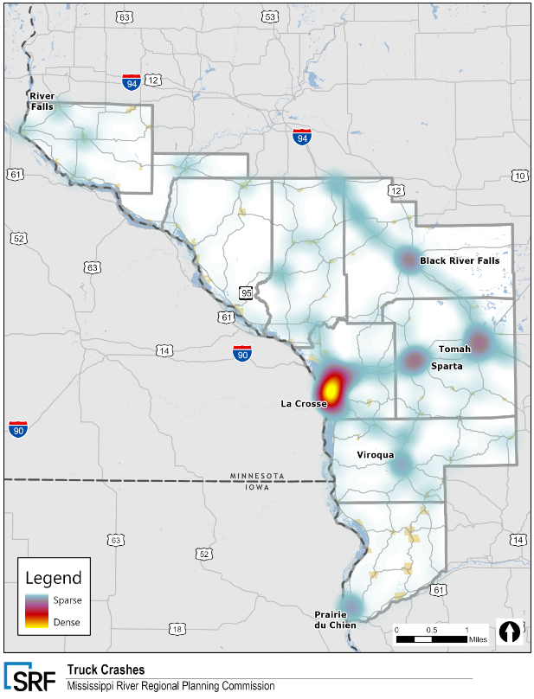
Figure 28: Truck Parking Utilization (Coming from WisDOT)

Rail Safety
Rail grade crossing safety is of critical concern in the MRRPC area due to the high-volume and highspeed railroads in the region. Several highway corridors are hot spots for rail crossing incidents due to each accommodating high volumes of traffic and daily trains. Although vehicle-train collisions are relatively rare, grade crossing incidents have a greater probability of resulting in severe injury or death over other types of traffic crashes. Figure 29 illustrates the crossings in the region with incidents over the past five years. In total, there have been twelve crashes that meet FRA criteria for being included in the Wisconsin Highway-Rail Grade Crossing SAP.

Figure 29: Public At-Grade Crossing Incidents
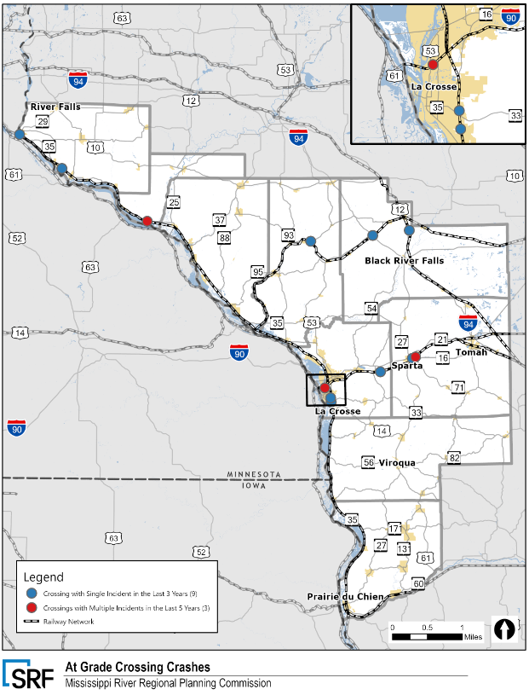
Appendix A

Appendix A: Relevant Maps and Other Graphics

Figure 30: Southwest Wisconsin Region Freight Flow (Tonnage)
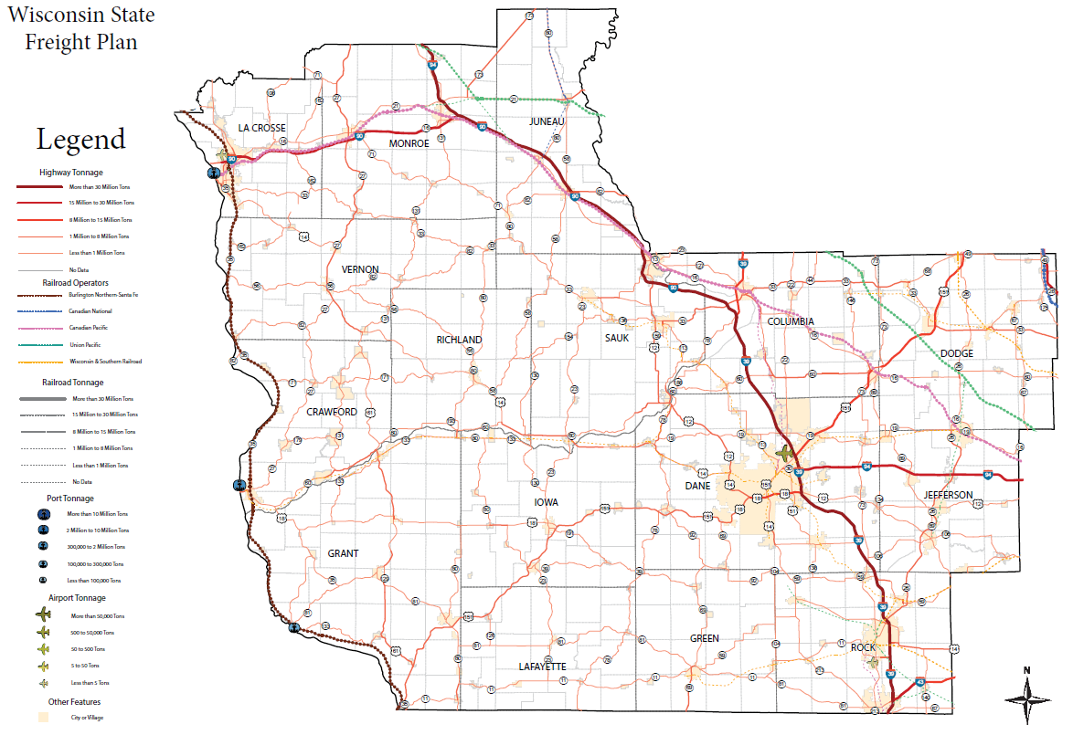
Figure 31: Southwest Wisconsin Region Freight Flow (Value)
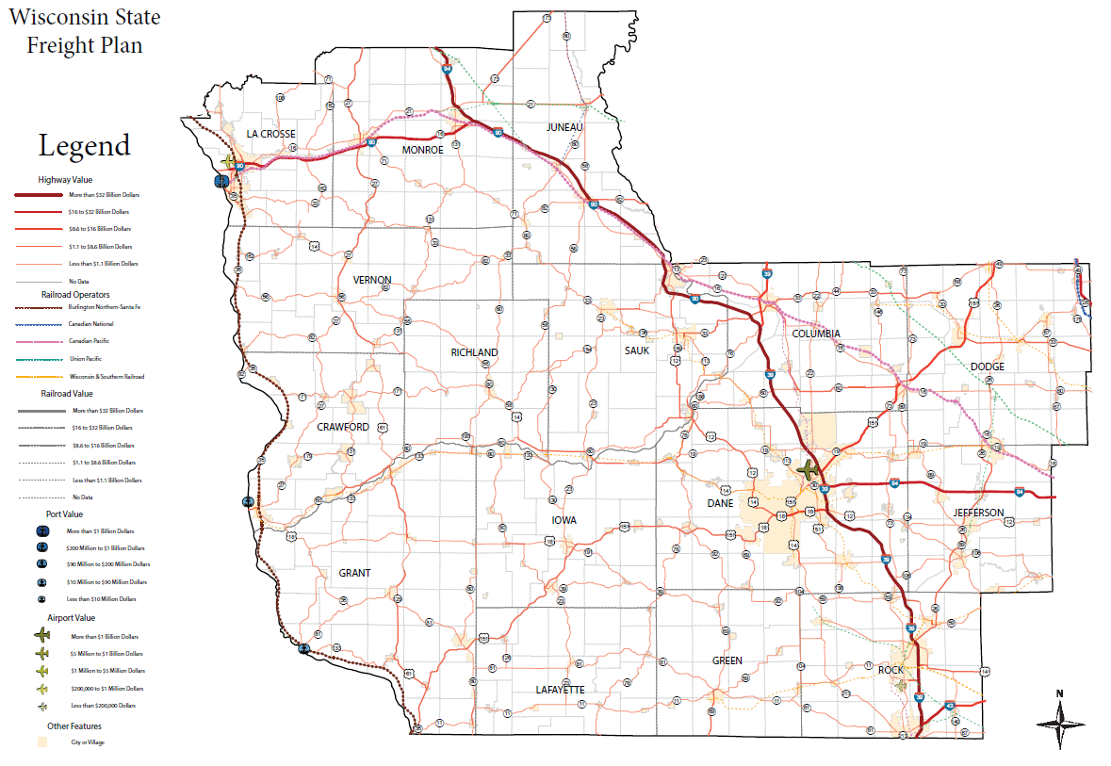

Wisconsin Department of Transportation. Wisconsin State Freight Plan. Accessed online at: https://www.wisdotplans.gov/plan/state-freight-plan
Wisconsin Department of Transportation. Wisconsin State Freight Plan. 2018.
Wisconsin Department of Transportation. Wisconsin Highway-Rail Grade Crossing State Action Plan. 2022. Accessed online at: https://wisconsindot.gov/Documents/projects/multimodal/rail/crossing-sap.pdf
Wisconsin Department of Transportation. Wisconsin Highway-Rail Crossing State Action Plan. 2022.
Wisconsin Department of Transportation. Wisconsin Rail Plan 2030. Accessed online at: https://wisconsindot.gov/Pages/projects/multimodal/railplan/2030.aspx
Wisconsin Department of Transportation. Bureau of Planning and Economic Development.
Wisconsin Department of Transportation. Bureau of Structures.
Wisconsin Department of Transportation. Wisconsin State Freight Plan. 2018.
https://wisconsindot.gov/pages/travel/road/rest-areas/default.aspx
http://www.driftlessdevelopment.com/business-advantages/transportation-logistics/
https://content.govdelivery.com/accounts/WIGOV/bulletins/31032b8
https://www.faa.gov/airports/planning_capacity/passenger_allcargo_stats/passenger/media/cy20-commercial-service-enplanements.pdf
https://www.faa.gov/airports/planning_capacity/passenger_allcargo_stats/passenger/media/cy18-commercial-service-enplanements.pdf
https://colgan-air.com/
https://www.ashleydistributionservices.com/Intermodal.html
Transearch. IHS Markit. Provided by WisDOT.
https://www.wsj.com/articles/wisconsin-fracking-sand-jobs-11602104015

